Hi XXXX,

Thanks for connecting back on LinkedIn, I did try to reach out on their messaging app but not sure how active you are on there.

I thought I would drop you a quick note as I am keen to setup a call to discuss our new ‘CEO/COO Showcase’ series - 'The Journey to Strategic Business Transformation & Digital Disruption' for the next editions of Business Chief Asia and Construction Global.

We are creating a number of 'Digital Reports' from senior execs talking about:  
﻿  
• Leadership and Strategy 4.0

• Technology Transformations

• Digital Disruption Initiatives

• Change Management & Talent Acquisition

• Cloud & Big Data

• AI/Machine Learning

Let me know if you fancy a chat in the next few days to discuss the potential of an interview about your own ‘Digital Disruption/Business Transformation’ plans, below are the latest editions of the magazines as well as a couple of examples of our brochures that are custom built post magazine, just click the covers:

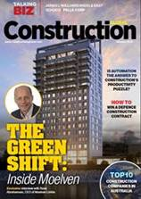 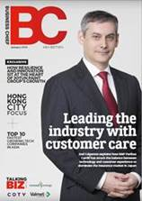   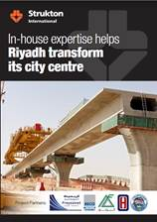 

Let me know if this is of interest as I would like to try and set up a call in the next few days?

Thanks,